**Project : CD/CP**

**App Host in EC2 Server(Using Vpc,Iam,EC2,S3,CD,CP,R53)**

**Output:**

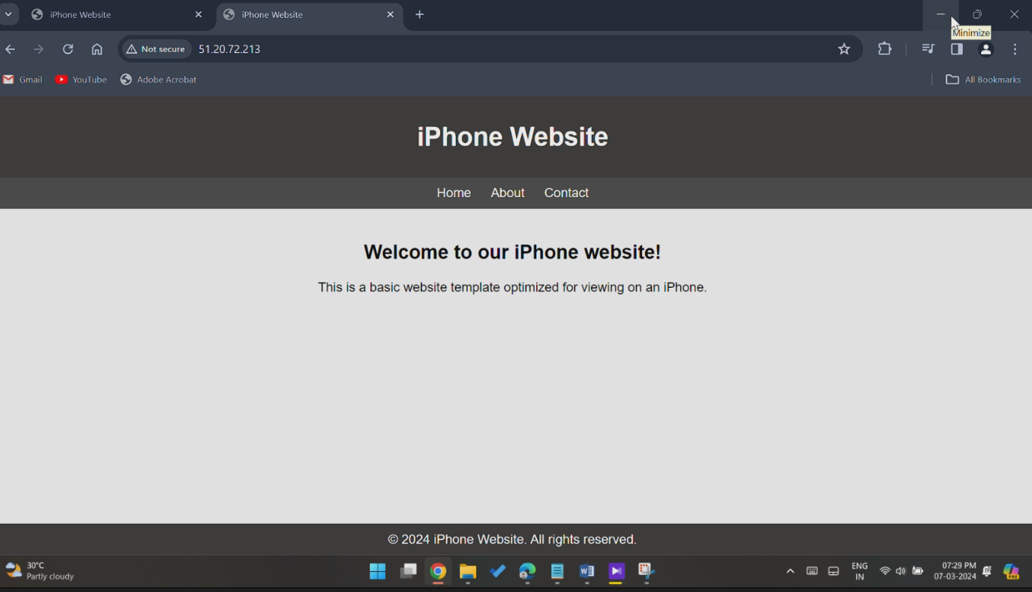

**Final Output:Pipeline Trigger:**

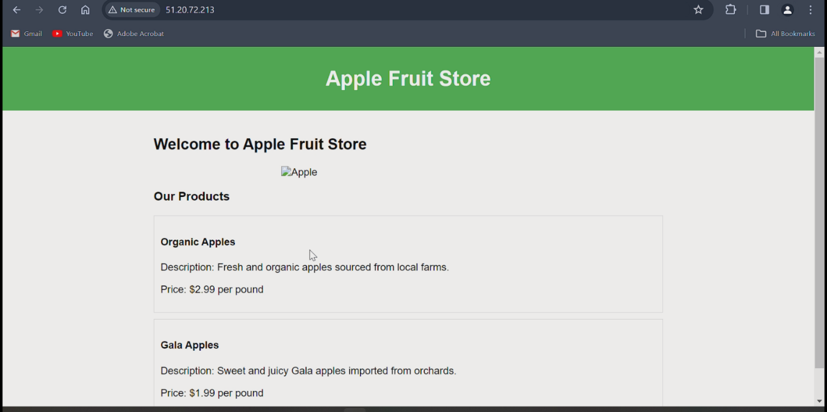

**Step1: VPC:**

**-Subnet, Route Table, IGW, Route & Route association.**

**Step2: IAM**

**-User & roles created and attached to EC2 servers**

**Step3: EC2**

**-Using VPC & subnet I created 2 EC2 instances with roles/user attachments & application files created.**

**Step4: S3**

**-Bucket created & uploaded zip format object from developer EC2 instances.**

**Step5:Code Deploy**

**-App creation with IAM role permissions, code deploy from s3 to Production EC2 instance / server. Using public Ip page Hosted in browser.**

**Step6: Code Pipeline**

**- Pipeline created and attached IAM role monitor updating of s3 bucket object. Webpage hosted in Updated manner.**

**Step7: Route53(Optional)**

**- Hosted zone & record created. Nameservers changes made in purchased domain. Using domain name webpage have to host but it takes too long for me.**

**VPC Creation**

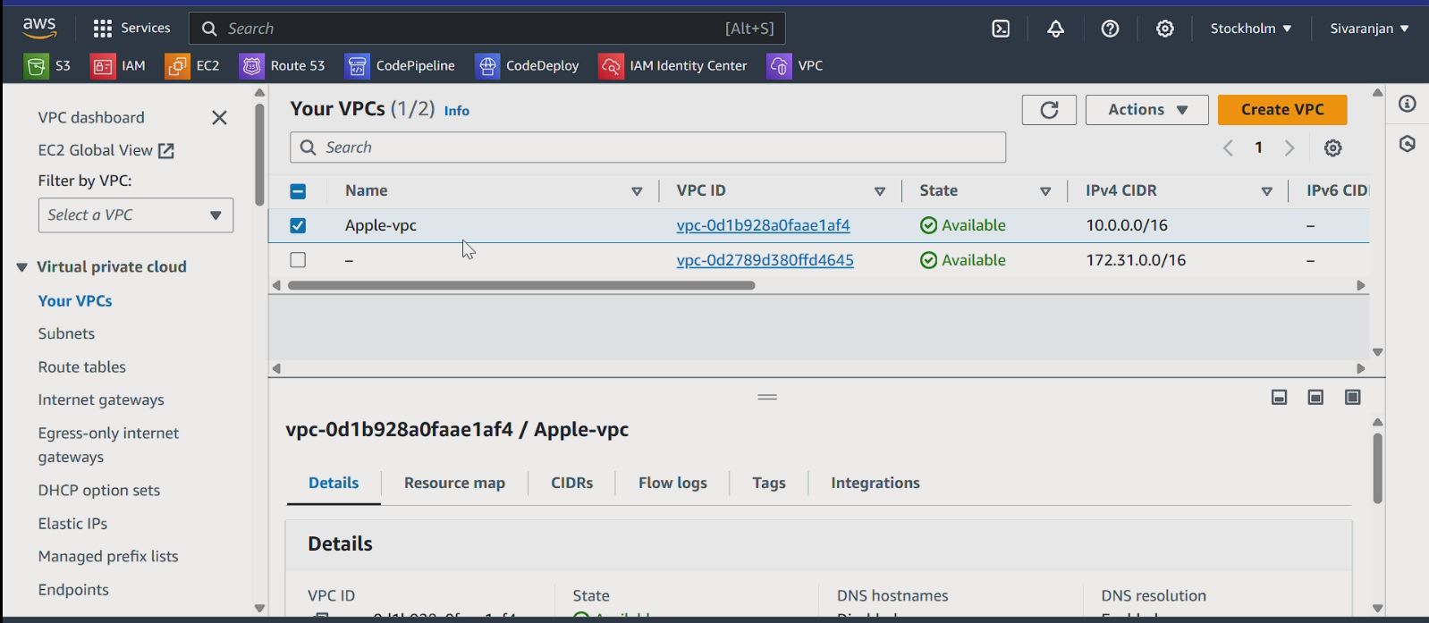

**IGW creation & associate**

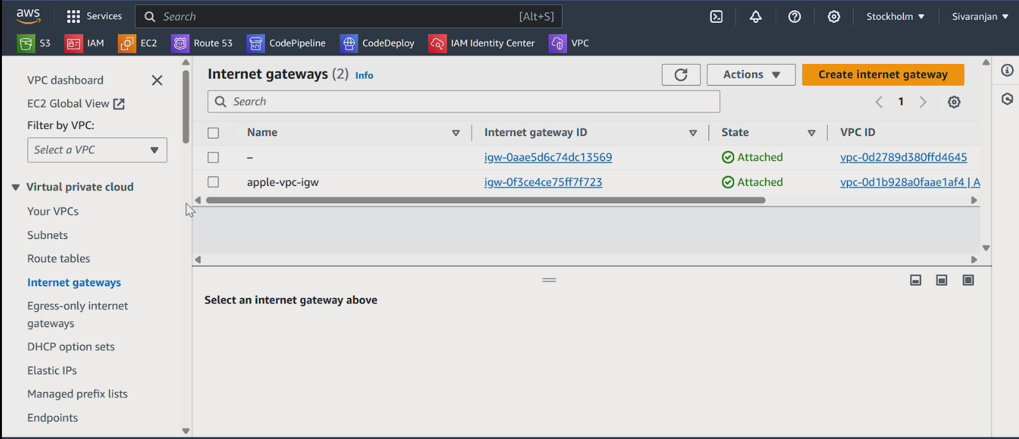

**SUBNETS CREATION**

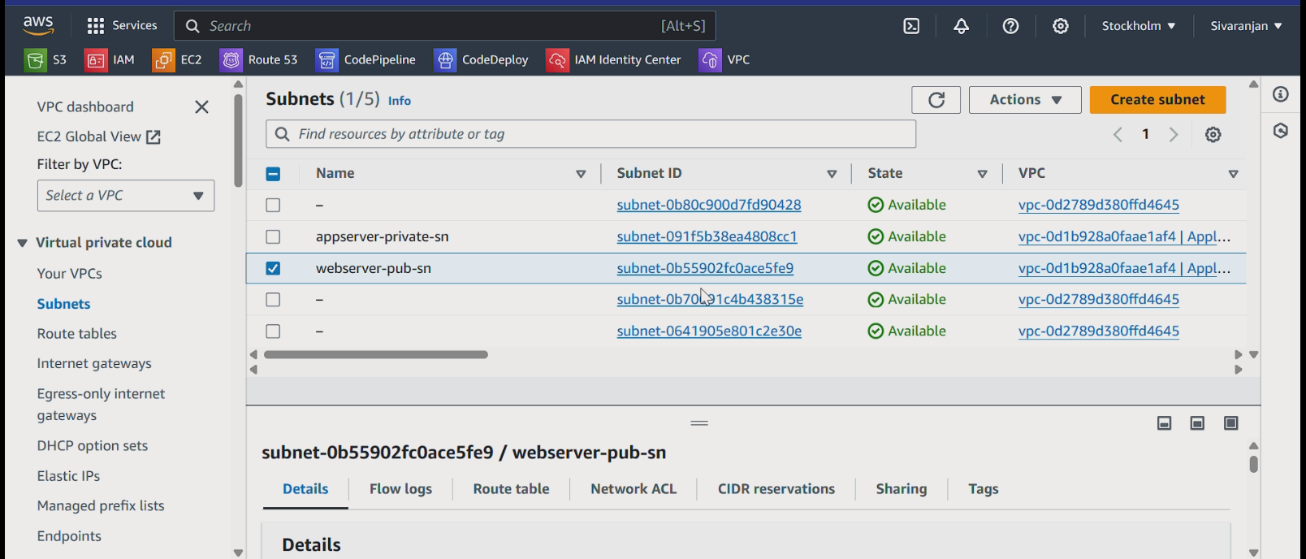

**ROUTEING TABLE CREATION AND CONNECT SUBNET & ROUTES**

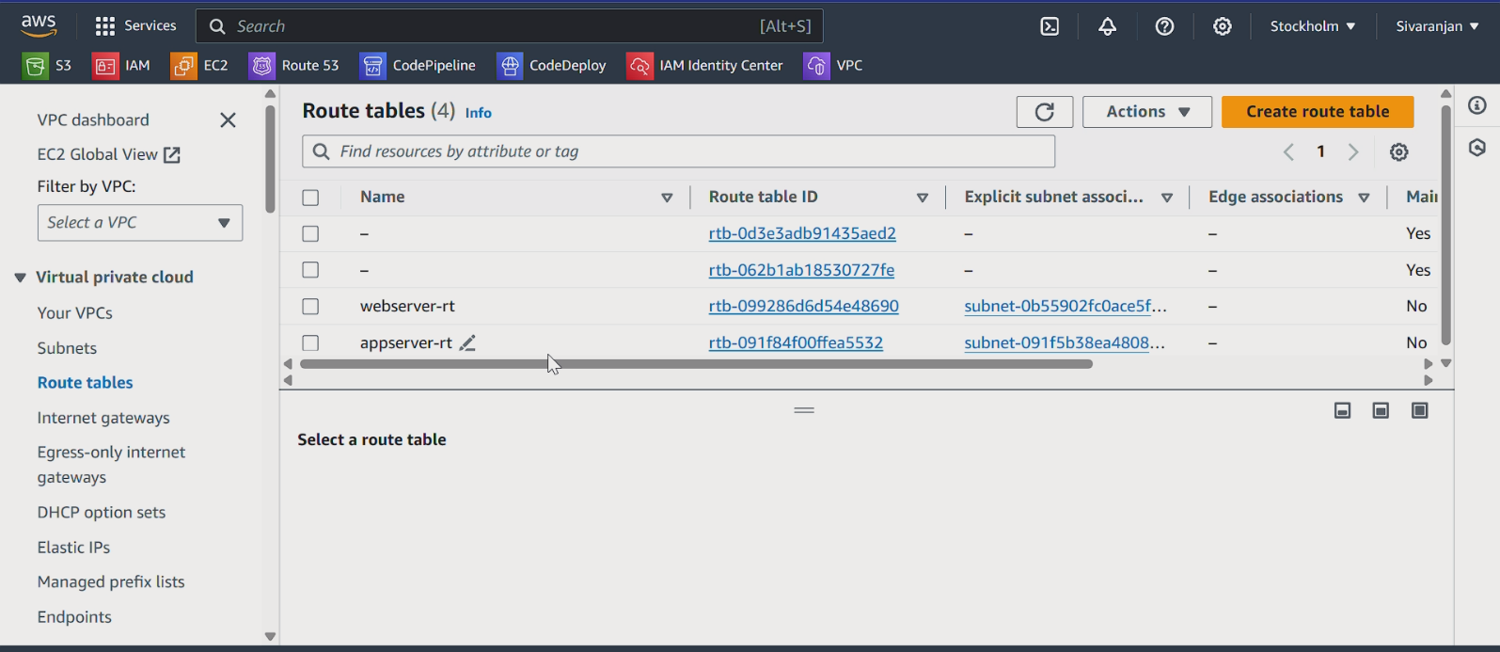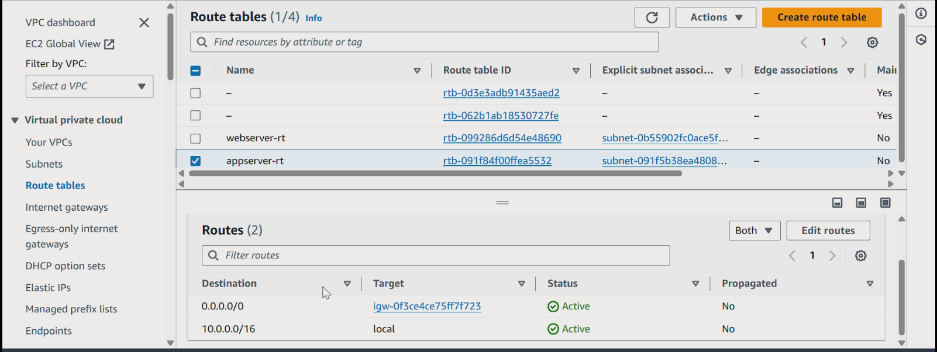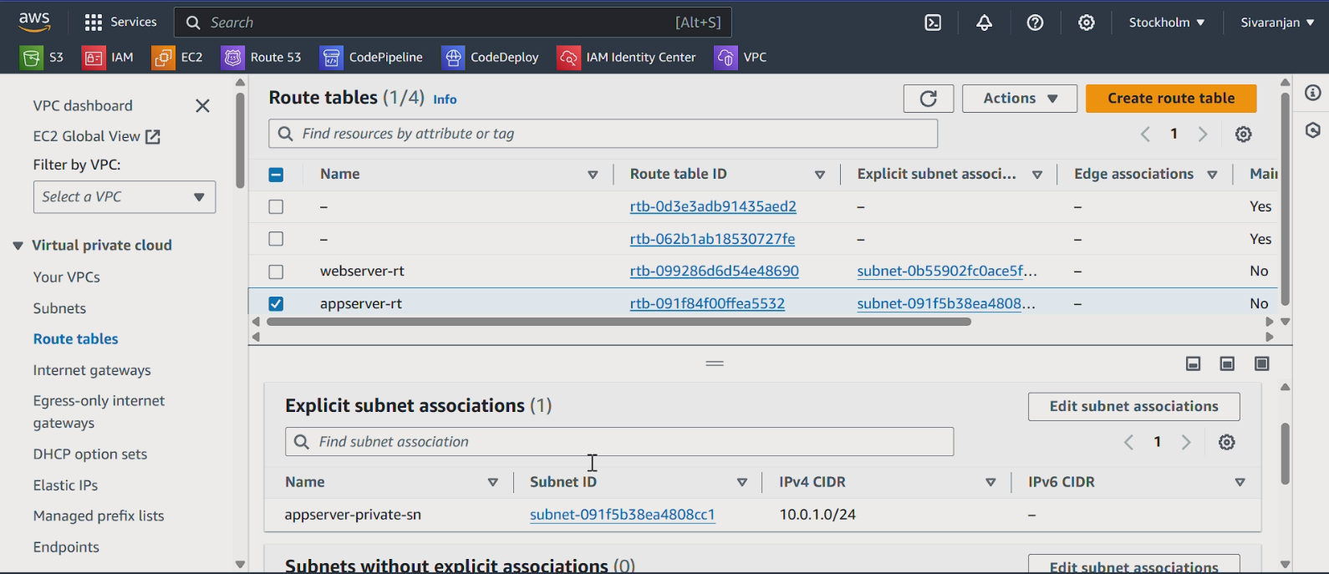

**IAM USER & ROLES CREATION WITH ATTACHED POLICIES**

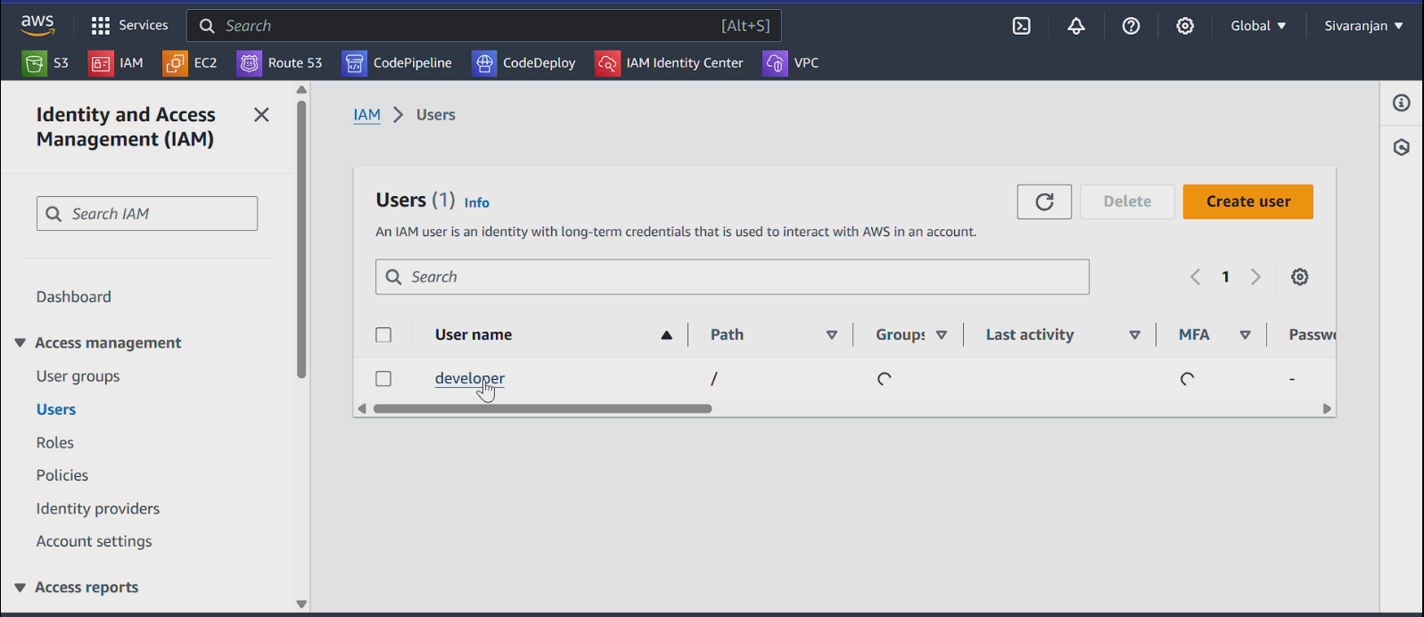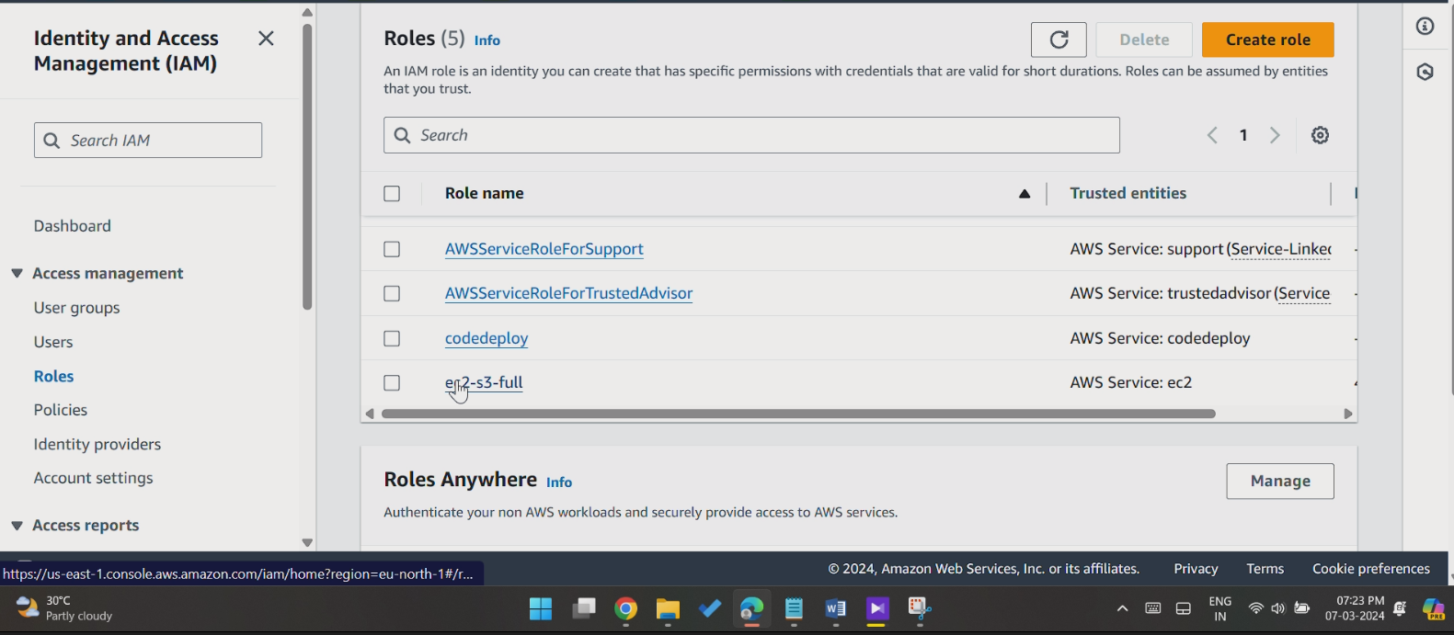

**EC2-CREATION UNDER VPC SUBNETS**

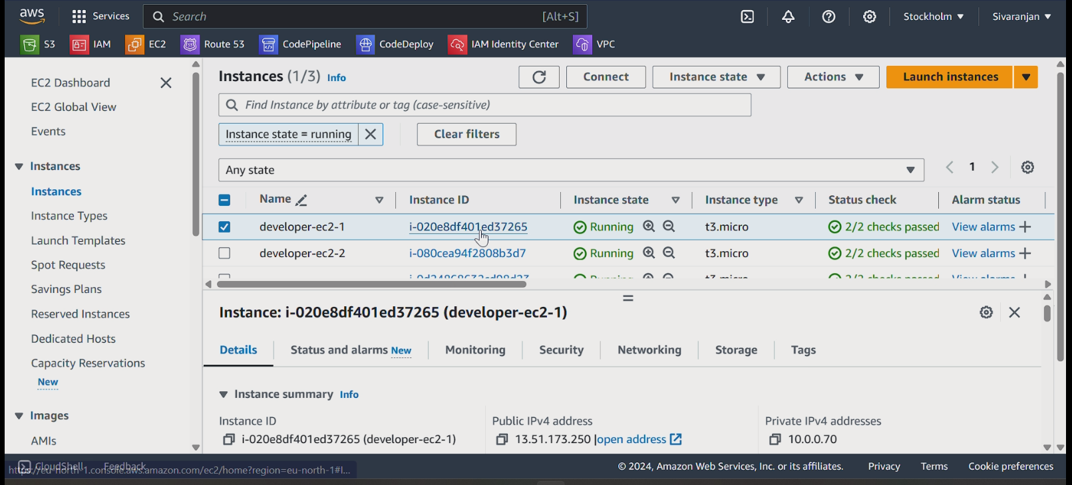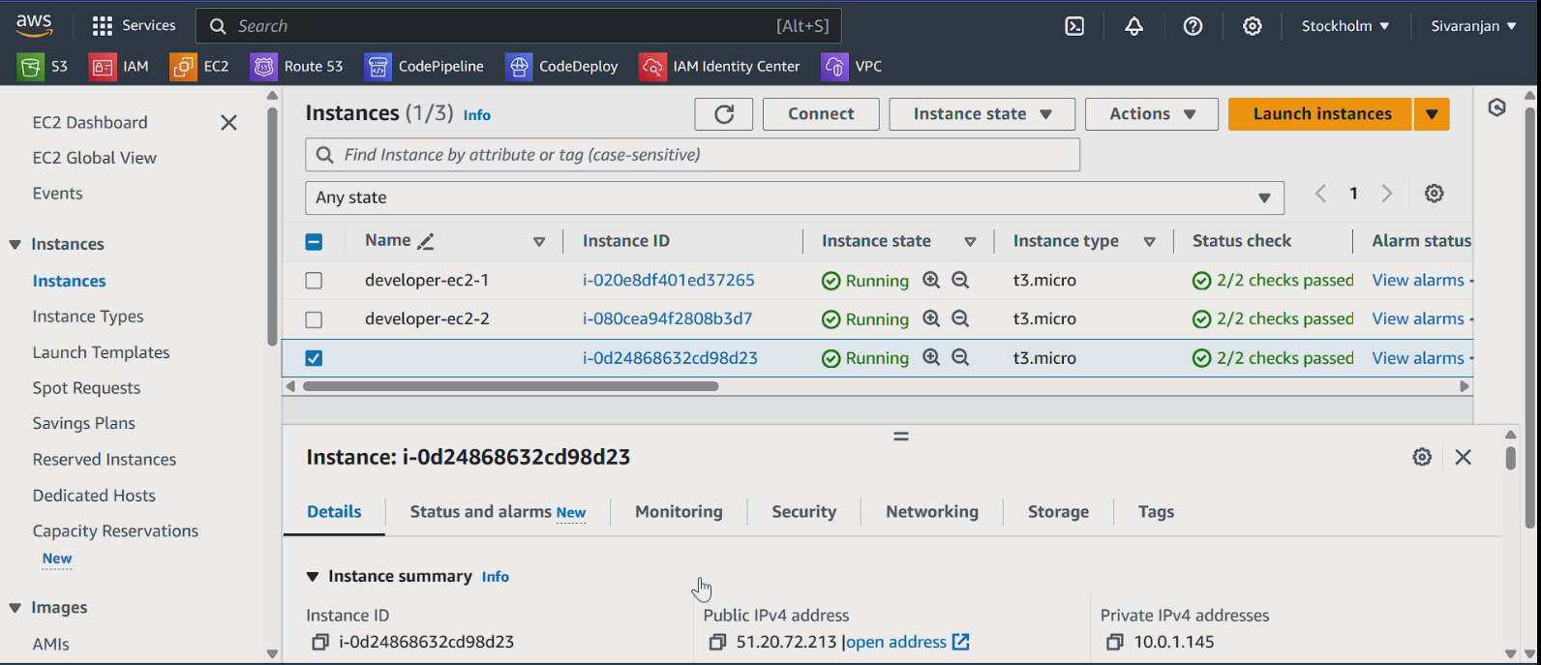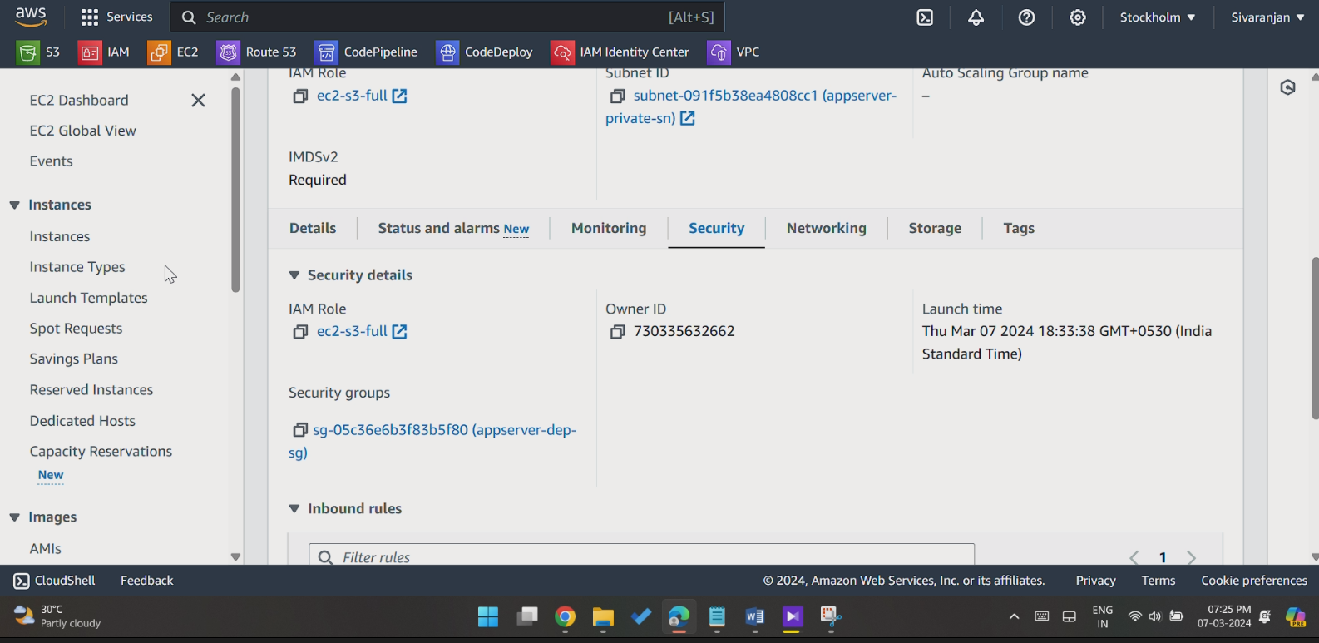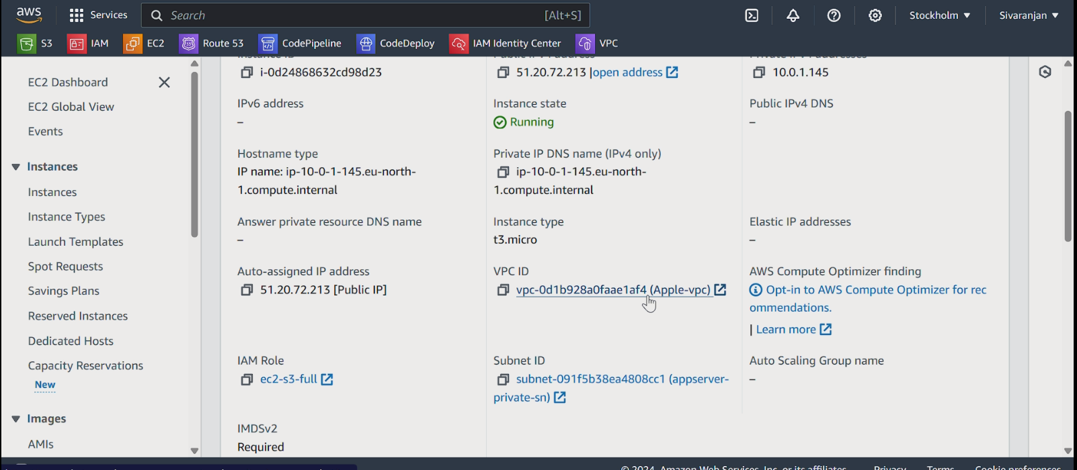

**S3 CREATION & OBJECT UPDATION**

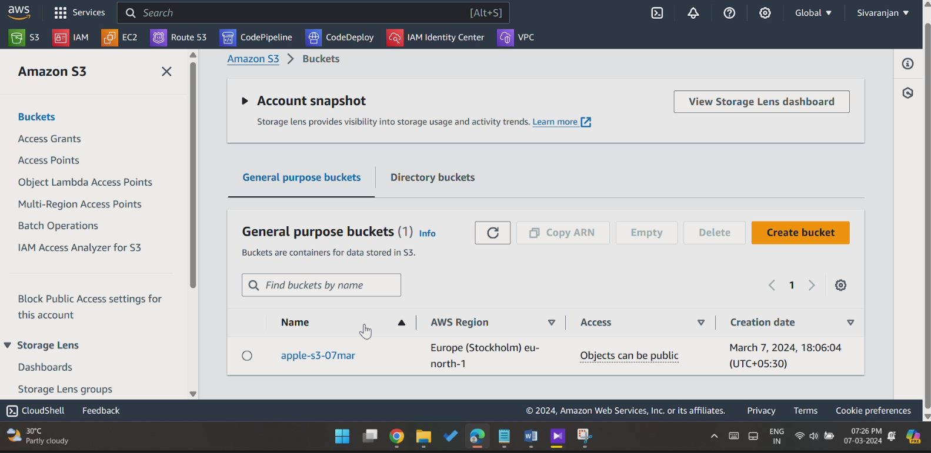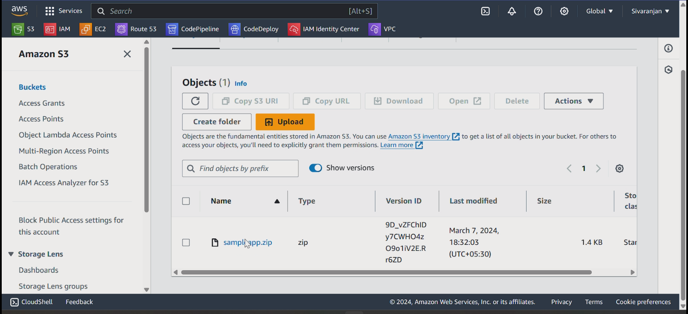

**CODE DEPLOY APPLICATION CREATION & DEPLOY**

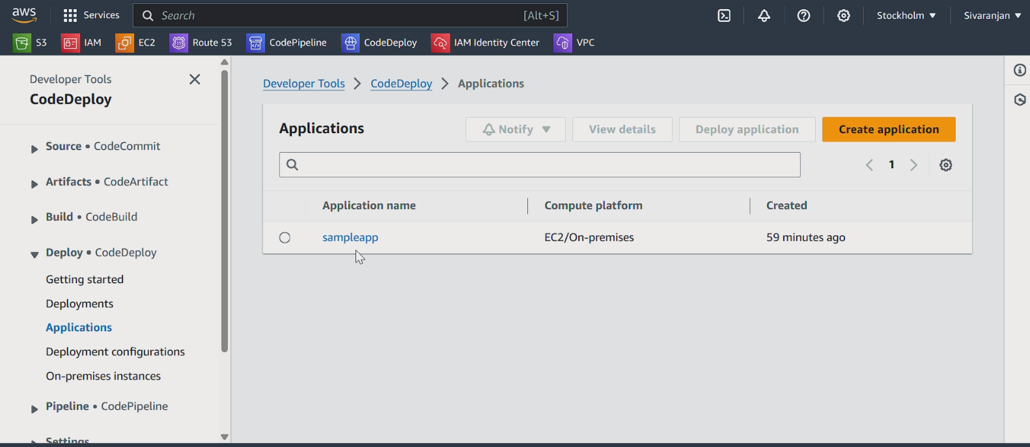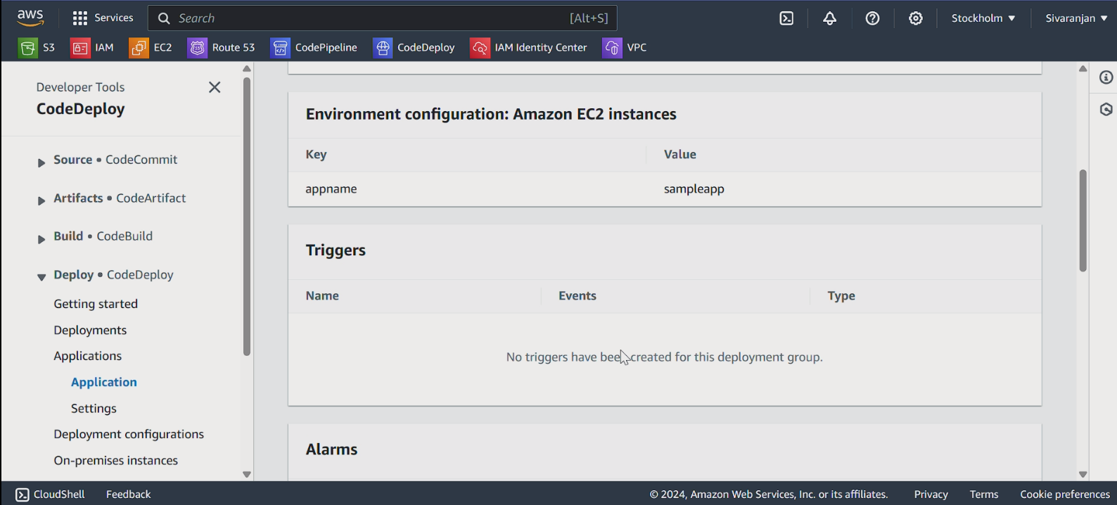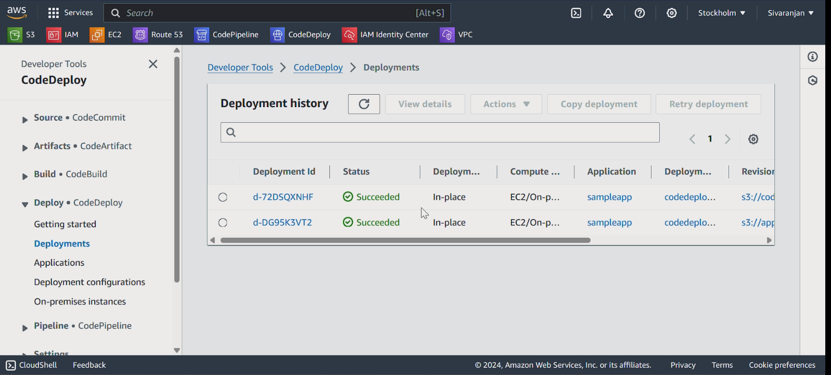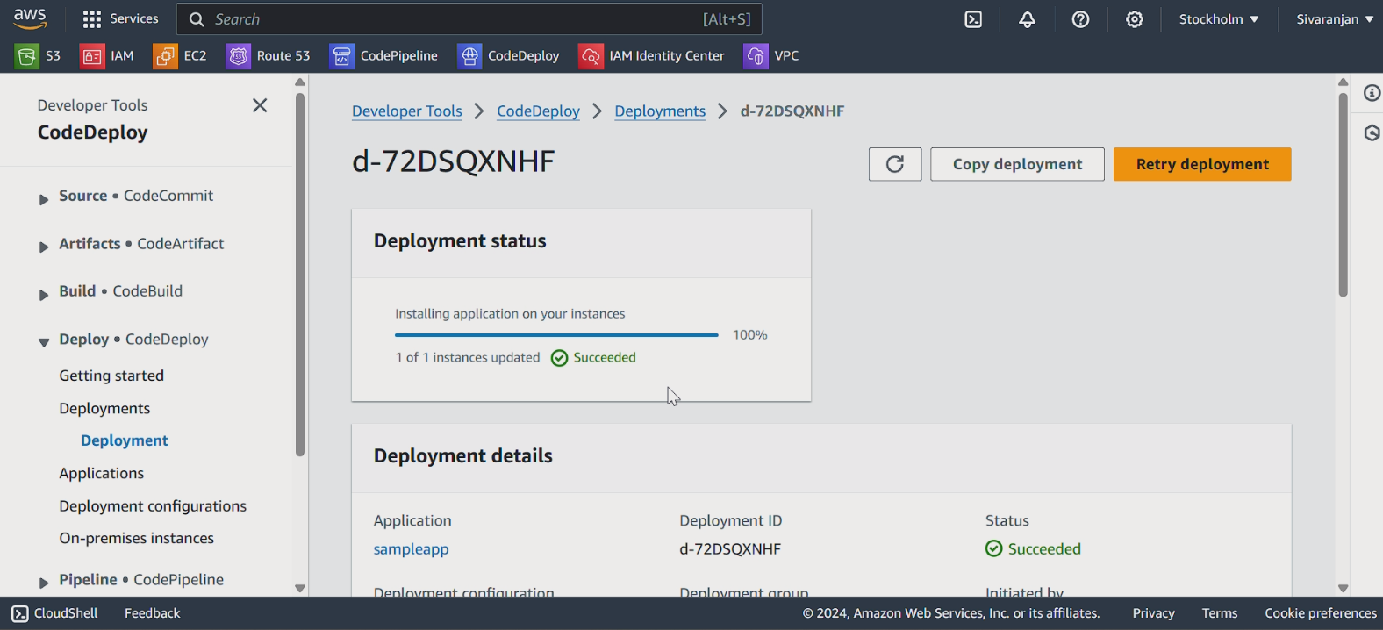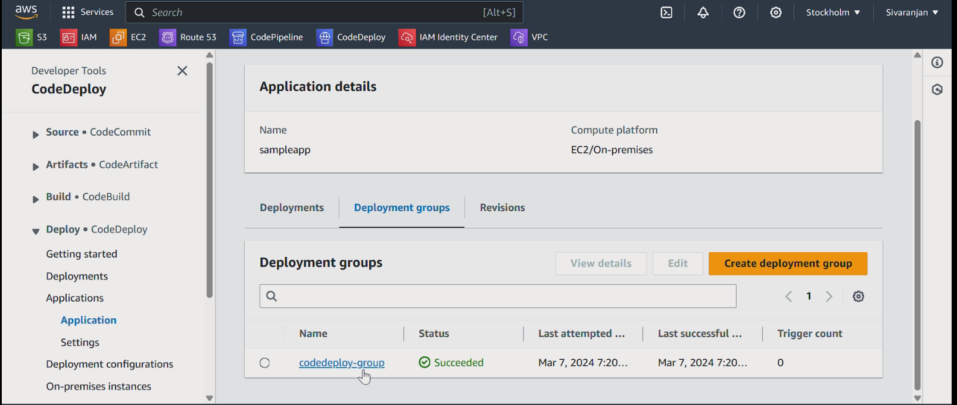

**CP CREATION & ATTACHMENTS**

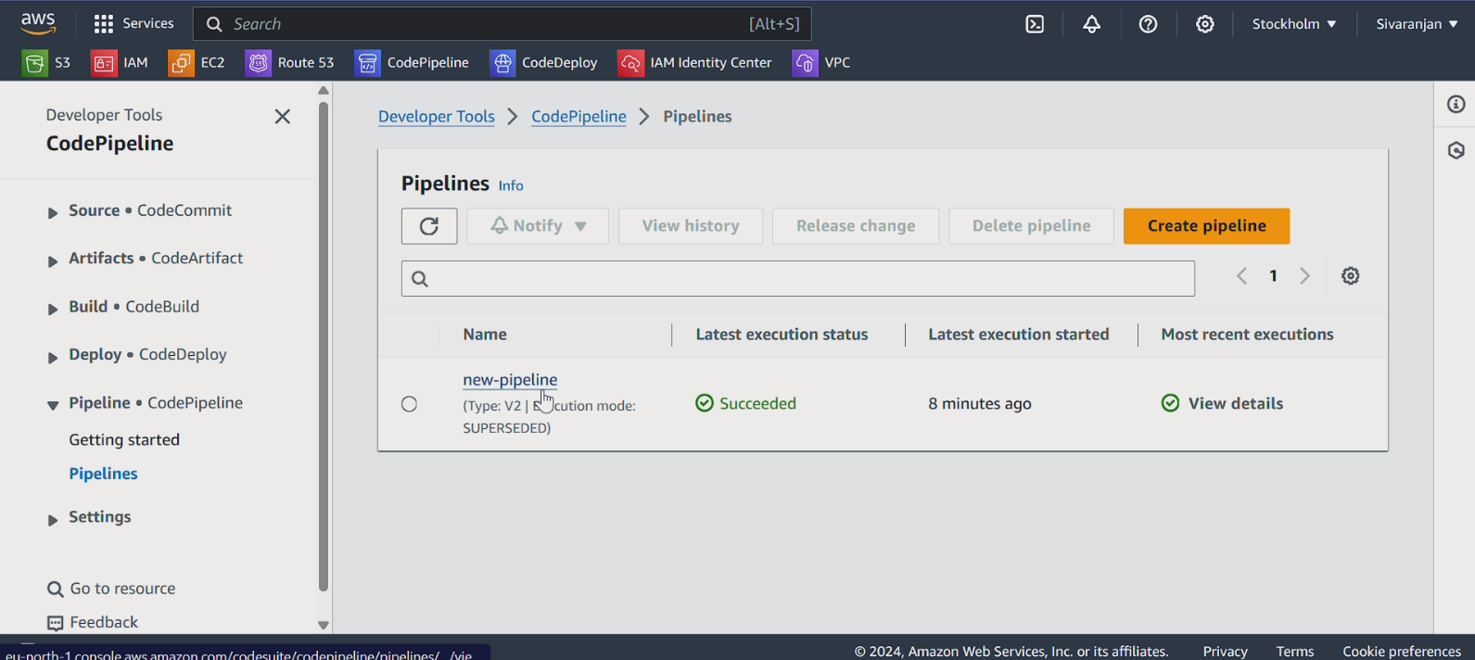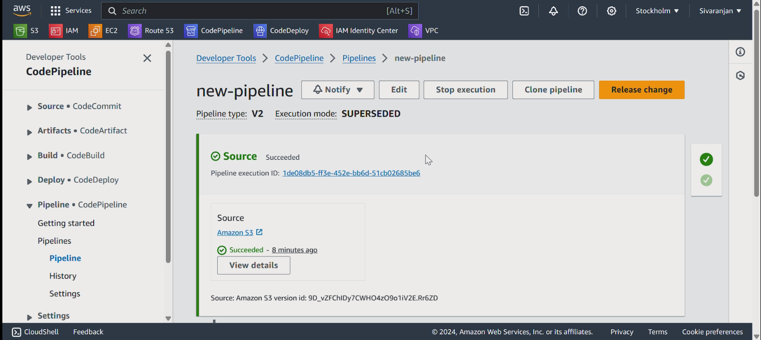

**WEBSITE HOST**

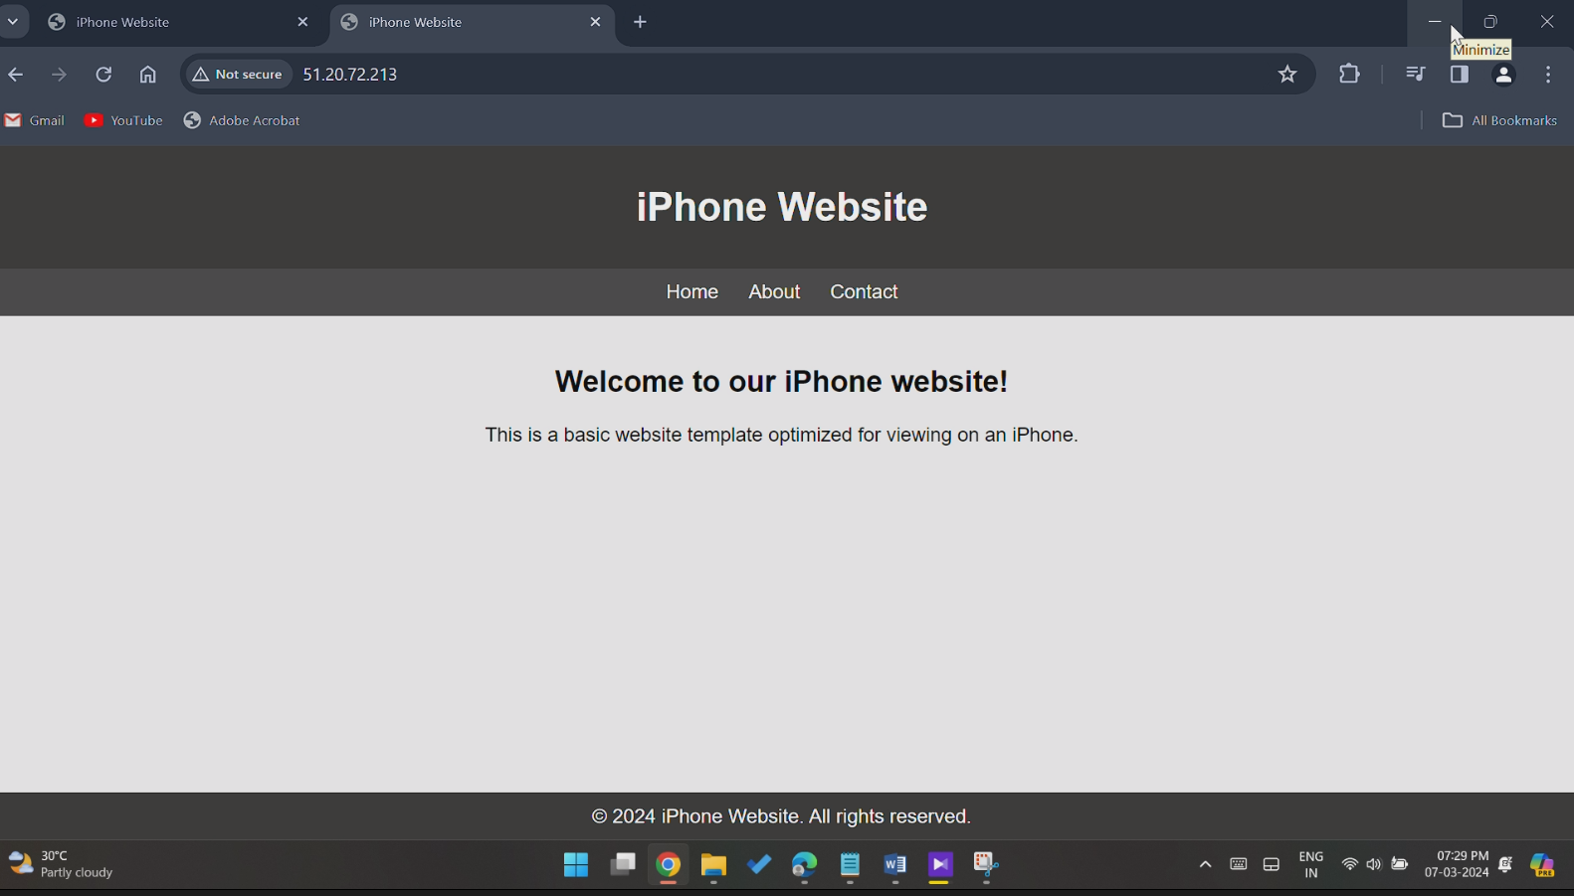

**S3 BUCKET AFTER VERSIONING**

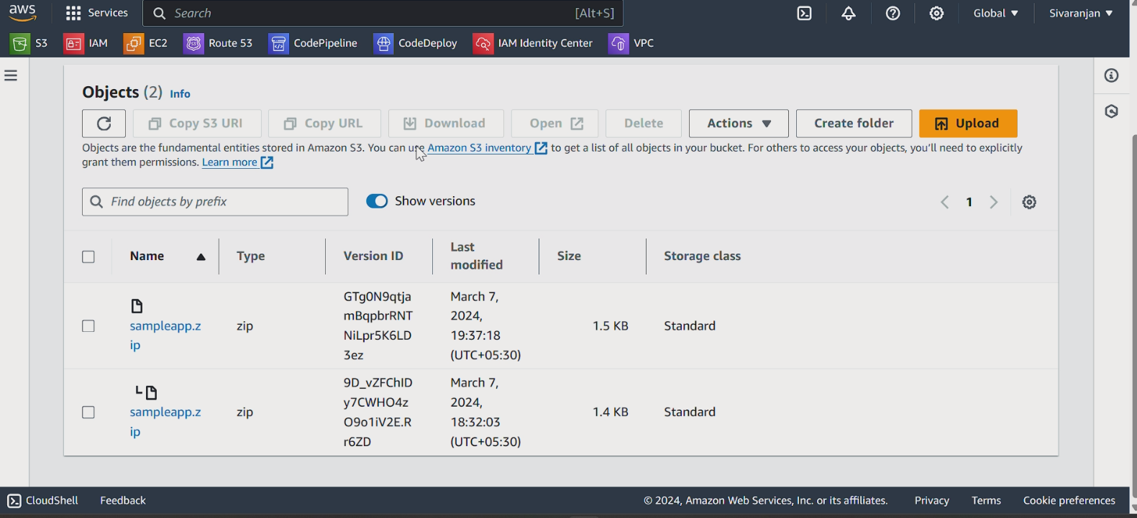

**CP TRIGGERS**

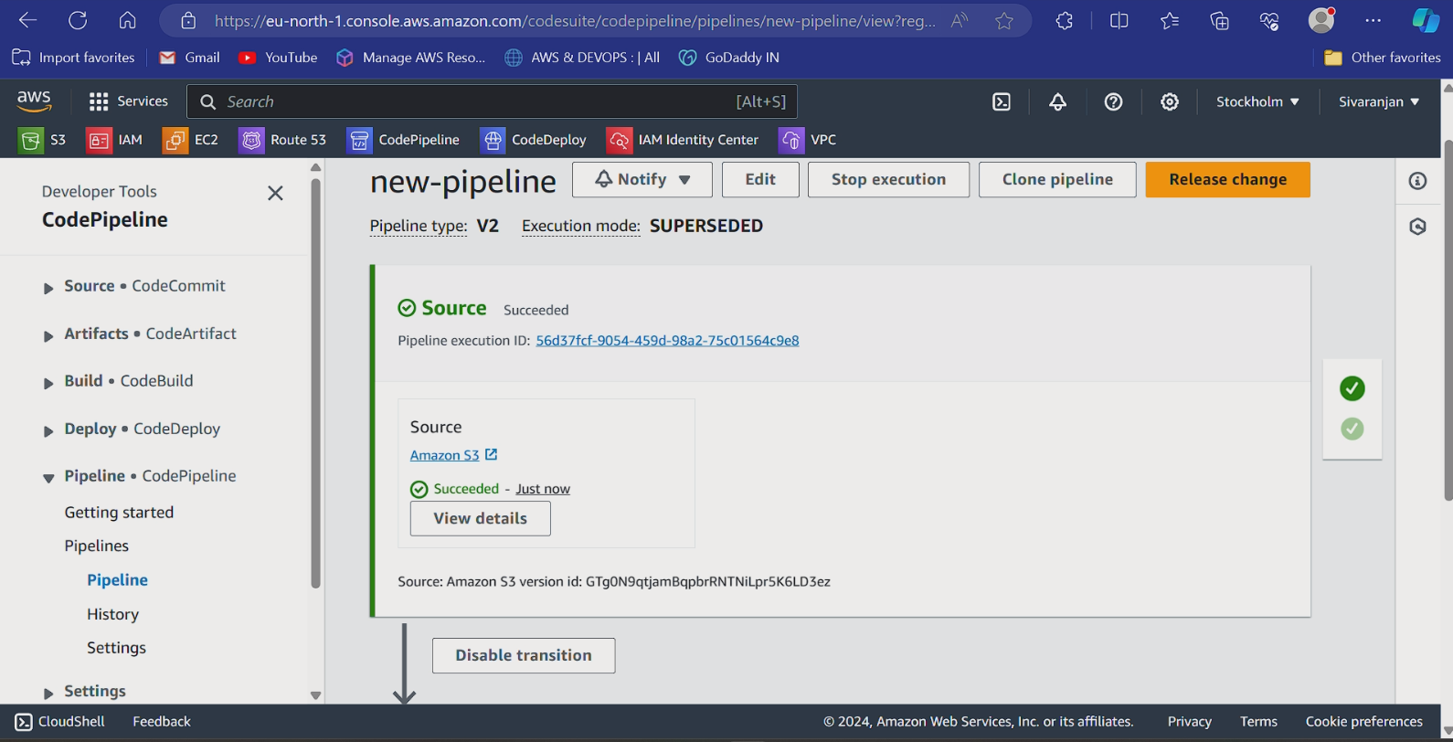

**UPDATED – WEBSITE :**

